Sentiment Analysis on Amazon Products Review Data

Rashi Goyal

University of Washington

Abstract

In today’s hi-tech analytical world, vendors and product manufactures are very observant of customer reviews about their products or competitor’s product performance in market. It is becoming extremely important in modern times to reduce costs and make more profit. To Achieve this, vendors are investing more time and money on mining reviews to get information about products’ popularity among consumers. Traditionally businesses relied on surveys, workshops and focus groups to gain insight into their customers’ opinions and feelings, but today with modern technology, we can harness the power of Machine Learning and Artificial Intelligence to extract meaning from text and dive into opinions of customers and see them outside of the often-controlled environment of a survey. This research tries to simulate Sentiment Analysis on Product Review data. Sentiment Analysis is the process of computationally identifying and categorizing opinions expressed in a piece of text, especially to determine whether the writer's attitude towards a topic, product, etc. is positive, negative, or neutral. This paper presents a framework to determine the polarity of the sentiments of costumer reviews using Machine Learning algorithms.

*Keywords:* Sentiment Analysis; Review data mining

**INTRODUCTION**

Nowadays, Consumers do not wish to spend time and energy in visiting shopping malls or retail stores. With increasing popularity of online retail shopping websites and availability of products within couple of days is widely accepted by consumer industry. Consumers can even buy products from different countries and get them delivered at their door step in no time. But, online shopping comes with a great dilemma, whether a product is good or bad (e.g. if the size of a certain dress is going to fit or not, sound quality of a Bose headphone is clear or not etc.). For this reason, consumers look for one very important thing that is a product review. As consumers are increasingly expressing their opinions about the products they use and their online shopping experiences, huge amount of customer reviews are available for data mining. This data is extremely valuable to customer as well as vendors and Manufactures to determine the popularity of their products. Also, this data can be very helpful in analyzing Industry trends (e.g. Consumer Trend, Product Quality, Service Quality, Marketing Strategy). However, extracting information from a product review is not as easy as it appears, as there may be thousands of reviews for one product on different shopping websites. Reading even a small share of the information is by itself a difficult cognitive challenge. Consequently, in recent years there has been a tremendous amount of work on automatically analyzing the sentiment expressed in natural language text. The field of research associated with this problem setting is generally denoted as sentiment analysis or opinion mining. In general, sentiment analysis addresses the problem of automatically identifying and analyzing subjective information in natural language texts. The goal is to determine the author's opinion about a specific target, or more abstract, about a specific topic.

The data used for sentiment analysis is unstructured and full of ambiguous and irrelevant information (e.g. Spelling mistakes are most common in extracted data). Application bugs also introduces lot of noise in review data that has no contribution in expressing user review and sentiments. Main goal of this research is to clean these noises and process this data to classify the polarity of the consumer sentiments i.e. to predict user sentiments as “Positive” or “Negative”. Most previous works consider the review as an instance of a text categorization problem and experiment with different machine learning algorithms and varying feature representations. However, for many application scenarios this document level classification of reviews does not provide the required level of detail. Challenging task is to classify sentiments from texts which has mixed reviews. A consumer can be expressing negative sentiment on the product he bought but can also be praising another product in the same review (e.g. The Oatmeal is not good. Its mushy, soft, I don’t like it. Quaker Oats is the way to go). It is clear from this example that consumer did not like the Oatmeal but is also expressing positive sentiments about different product in this product’s review. So, there may be a risk of considering this as “Positive” sentiment by some models as it has both “Negative” and “Positive” words. To classify consumer reviews, the approach considered in this paper is to use every word in the review text as a feature for training and classification. So, the tasks can be summarized as

1) Feature Reduction

2) Cleaning data and remove all special characters (i.e. noises from the data)

3) Applying porter stemming

4) Classify these reviews into “positive” and “negative” sentiments.

In this paper, the main focus is on the forth subtask, i.e., detecting sentiment expressions and their polarity. The major share of current review mining approaches involves the use of special purpose dictionaries for this task. Such resources encode information about the sentiment polarity of individual words or phrases, i.e., an entry is associated with categories like positive, negative, or neutral polarity. During text analysis, this information (often in combination with further linguistic clues) is then used to determine language related indicators for evaluative content. For instance, an occurrence of the verb “like" generally indicates a positive or affirmative sentiment. When constructing a sentiment vocabulary list, one major challenge is that the actual sentiment polarity of an expression is often dependent on the context. In fact, the polarity of a specific term may differ from domain to domain or may even differ within a single application domain, depending on the concrete target (e.g., digital cameras: long battery life" vs. long flash recycle time"). Although this phenomenon is known, most approaches focuses on creating general purpose dictionaries. However, especially in the context of customer review mining, the use of such dictionaries is rather suboptimal as they fail to adequately reflect the domain-specific usage of word. In this research, all words in the sentence are used as part of the review for training classifiers and predicting the sentiment. This research follows a key-value pair approach where all the words in a sentiment text will be considered as an input for training the machine learning algorithms. Several dictionaries will be created for the initial parts of the research to clean the data. After the data is cleaned, a key-value pair will be created for all the words in the dictionary where key is the actual word from the review and value is a Boolean value attached to it. These key-value pairs are then used as input for training the Machine Learning models.

**RELATED WORK**

As related studies, this section describes related works in the field of sentiment analysis and classification. With a growing interest in sentiment analysis, many researchers put some efforts for the task of sentiment dictionary generation, utilized conjunctions (e.g., “and” conjoins two adjectives which are equally polarized) as was also done by a group of researchers recently. Another group exploited WordNet by capturing word relations (i.e., antonym

and synonym) of sentiment related words and their glosses (e.g., the glosses of “intrepid” and “good” would share the same keywords). Most automatic approaches are either dictionary-based or corpus-based. Approaches in both classes have in common that they typically involve a seed set of pre-labeled examples. By testing the semantic similarity between unknown words and labeled seed words the sentiment status of new entries is derived.

***Dictionary-Based Approaches*:** Dictionary-based approaches typically rely on a thesaurus or on sentiment related word databases such as WordNet. A common assumption is that semantic relations such as synonymy transfer the sentiment polarity of related words. For example, the adjective “lovely" transfers positive polarity to its synonyms “admirable", “adorable", “amiable", “pretty", and transfers negative polarity to its antonyms “awful”, “unlovely”, “ugly". A further dictionary-based approach is to infer the semantic relatedness of entries by calculating similarity by means of the glosses. An obvious disadvantage of dictionary-based approaches is that they are typically unable to identify domain dependent sentiment words.

***Corpus-Based Approaches*:** Also with corpus-based approaches the basic idea is to calculate a measure of semantic relatedness between words and to use this to derive the sentiment status of new words or phrases. Examining these approaches more closely, mainly four different ways were identified to infer relatedness: co-occurrence statistics, distributional context similarity, linguistic clues, and structural clues. The general idea of co-occurrence can be hypothesized as the “semantic orientation of a word tends to correspond to the semantic orientation of its neighbors". Using the Web as a corpus, measures of association are applied, such as pointwise mutual information (PMI), to derive a correlation statistic of an unseen word with a set of positive and negative seed words. Besides inferring relatedness of two terms directly by their co-occurrence, a common approach is to define similarity indirectly by means of the words' context. It is assumed that words with a similar context also exhibit a similar sentiment polarity. Besides relying on purely statistical analysis, other studies propose to consider linguistic clues to determine the sentiment polarity of words. Using a natural language parser, adjective phrases are extracted from these sentences and statistic measures are applied to determine whether a phrase predominantly occurs in positive or negative sentences.

***Lexicon Adaption*:** More recently, researchers examine methods to adapt existing sentiment lexicons. Typically, the purpose of adaptation is either to augment a general-purpose sentiment lexicon to better fit a specific domain or to extend a monolingual lexicon to cover multiple languages. Domain adaptation is for instance is an approach based on linear programming, which expand existing lexicons by means of linguistic patterns. In addition to purely dictionary or corpus-based approaches, some researchers study the utility of hybrid approaches, which combine indicators from the different sources. For instance, in some papers, researchers have used semantic relations in WordNet to create an initial sentiment lexicon, which is then refined by incorporating statistical information gathered from the Web. Both information sources are combined by means of an error minimization algorithm. On combining four types of signals that indicate the sentiment polarity of words: Information is gathered from a general-purpose sentiment lexicon, from a thesaurus, from linguistic clues, and from structural clues in domain specific documents. The different signals are combined in an optimization framework that is based on a linear programming approach. In fact, we extended the previous approach. The major differences are the application of more robust extraction heuristics (incl. neutralization detection), the use of an aspect taxonomy (which groups similar aspects), and a different setup for statistical hypothesis tests. Experiments are also much more convincing, as the evaluation corpora are larger multiple state-of-the-art baseline methods for comparison are considered.

**APPROACH**

This paper addresses the task of predicting the polarity of product review data by cleaning the unstructured data, deriving dependent variables in the form of key-value pair and then using the dependent variables as an input for training the machine learning models. Figure 1 summarizes the complete process of training the model and predicting the polarity of the sentiment.

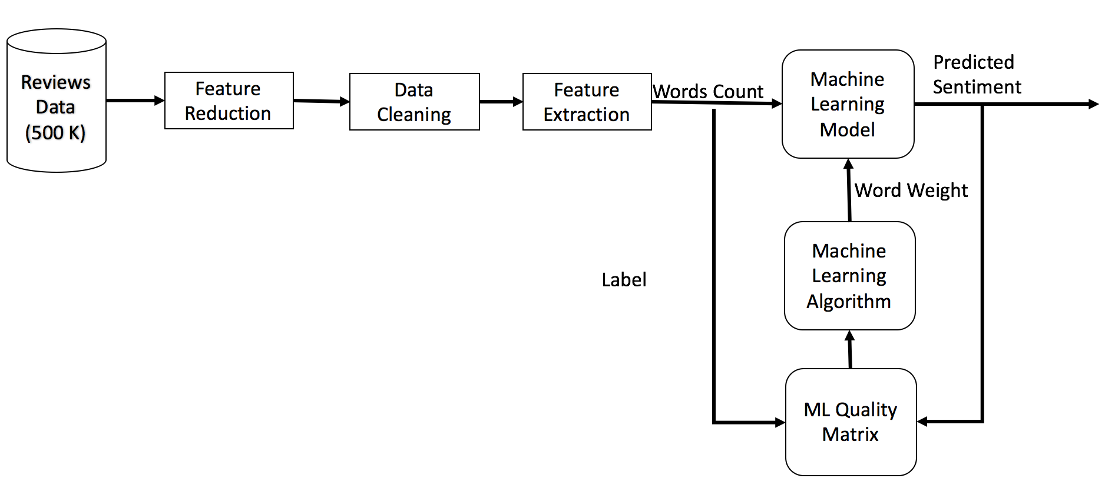

Figure 1: Sentiment Analysis Working Project Model

***Feature Reduction:*** Originally, this data set has nine Features as mentioned in the Figure 2 below:

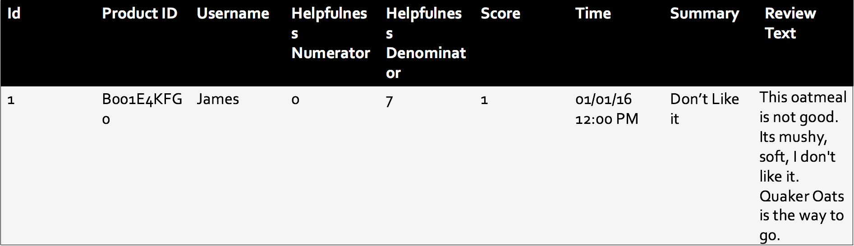Figure 2: Amazon Product Review Data

Originally, as it is shown that this data set has nine features but this project’s scope is limited to sentiment analysis which is performed on the basis on “Review Text” field. Hence, feature reduction is performed on this set as show in Fig. 3.

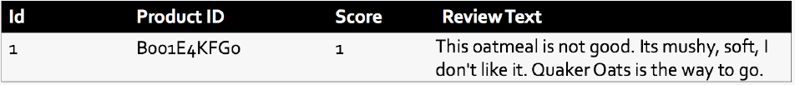

Figure 3: Reduced Dataset

These reduced features are the independent variables which in the next step are used to extract dependent variables.

*Id*: Unique ID for the product

*Product ID*: ID associated with the product Name

*Score*: Rating of the product by a customer

*Review Text:* Review about a product on basis of which classification is performed. All the words from this text will be used in the generation of key-value pairs for training the model.

Also, all the datasets with value of attribute score as 3 are also removed as the scope of this project is to predict only positive and negative sentiments.

***Data Cleaning:***Data cleaning is applied only to the review text field as this is the only attribute that will be used for creating the dependent variables and has all the information. After feature reduction, the raw data is processed through three cleansing procedures. 1) All the words in the review text are converted to lower cases 2) Special characters i.e. any character which is not an alphabet is removed 3) NTLK (Natural Language Took Kit) is used for applying porter stemming approach to the review text. Porter stemming is a method of reducing derived words to their base or root form. For example, words like Argue, Argued, Arguing, Argues, and Argus are all converted to its stem word “Argu”. This approach prevents same words to be interpreted in different manner by the classifier, it reduces noises in the data like spelling mistakes or typo error. Hence, it helps increasing the accuracy of the machine learning model as the words will be changed to their root word and context of the review will remain intact. Figure 4 shows some examples of the data after cleaning.

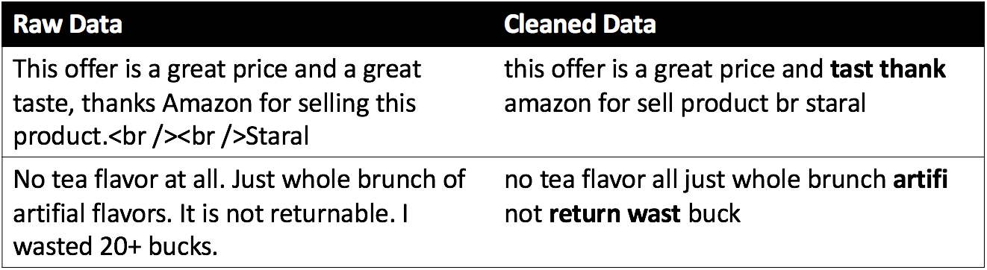

Figure 4: The difference between Raw data and Cleaned data

As shown in Fig. 4, after applying porter stemming, words like “taste”, “thanks” were converted to their root form “tast”, “thank”.

***Feature Extraction:*** After cleansing procedure, Dependent variables are derived from the “Score” and cleaned version of “Review text” field. Fig. 5 shows the final feature matrix.



Figure 5: Feature Matrix for training and classification

***Feature Matrix:*** All the words in the review text field after cleansing are transformed into a feature matrix. All the words in the “Review Text” are stored in a key value format. Key stores the word and value is a Boolean type of variable associated to that key.

*Label:* Each Matrix is labeled as “Positive” or “Negative” based on the review score. All neutral reviews with score three are excluded as a Neutral review increases the risk of wrong prediction by a classifier.

***Training the Model:***  The data is divided into two parts: 1) three-fourth of the data is used for training the model 2) remaining one-fourth is used for testing the accuracy of the model. As this is a bi-class classification, algorithms applied for classification are 1) Naïve Bayes 2) Linear Support Vector Machine 3) Logistic Regression.

**EXPERIMENT RESULTS**

The confusion matrix is a two by two table that contains four outcomes produced by a binary classifier. Various measures, such as error-rate, accuracy, specificity, sensitivity, and precision, are derived from the confusion matrix. Moreover, several advanced measures, such as ROC and precision-recall, are based on them. The binary classifier produces output with two class values or labels denoted as “positive” and the other as “negative”. This classification (or prediction) produces four outcomes: 1) true positive, 2) true negative, 3) false positive and 4) false negative.

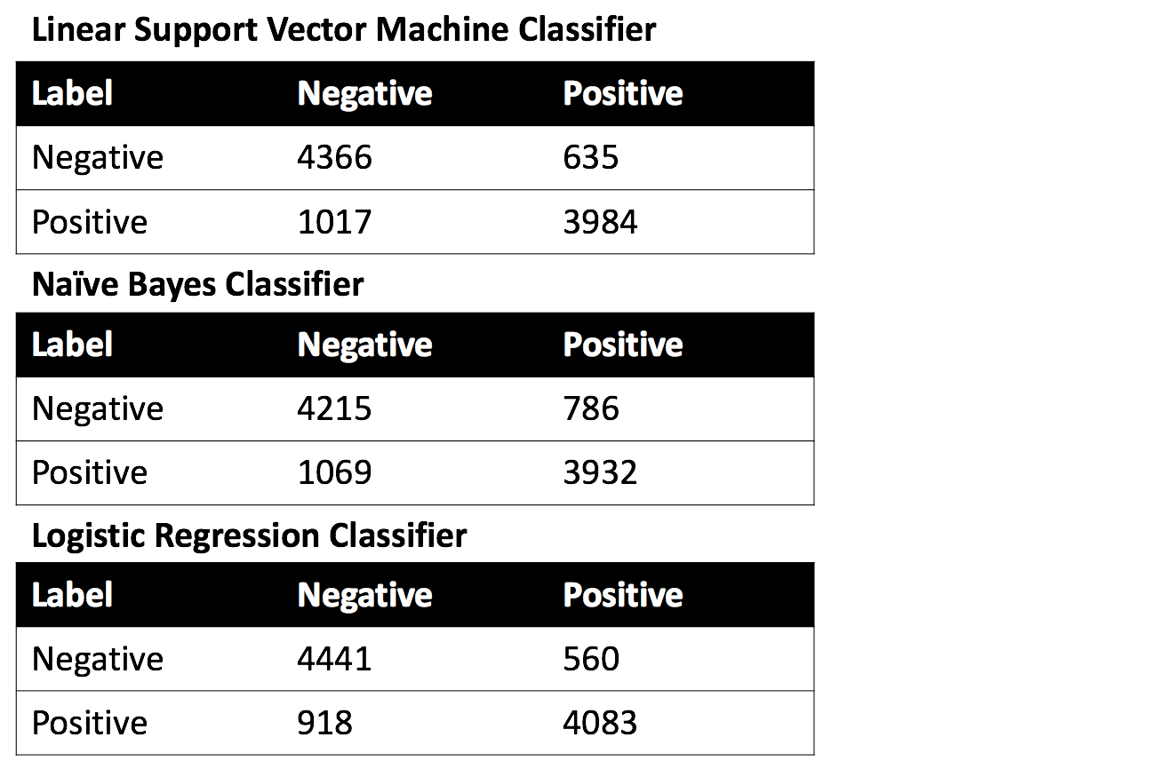

Figure 6: Confusion Matrix of applied algorithms

*Accuracy* is calculated as the number of all correct predictions divided by the total number of the dataset. The best accuracy is 1.0, whereas the worst is 0.0. It can also be calculated by 1 – ERR. The accuracy.



Figure 7: Accuracy of applied algorithms

As it can be seen in Fig. 7 that cleansing approach and porter stemmer has helped achieve good accuracy for all the algorithms. Though the accuracy does not differ much for different models but we can still see that the Logistic Regression has proven to be more accurate than other two.



Figure 8: Classification report of applied algorithms

*Precision* is calculated as the number of correct positive predictions divided by the total number of positive predictions. It is also called positive predictive value (PPV). The best precision is 1.0, whereas the worst is 0.0. Logistics Regression produces the best precision values out of the three applied algorithms.

*Recall* is calculated as the number of correct positive predictions divided by the total number of positives. It is also called recall (REC) or true positive rate (TPR). The best sensitivity is 1.0, whereas the worst is 0.0. As it can be seen from Fig. 8, Logistic regression has the best precision results.

**CONCLUSION AND FUTURE WORK**

In this paper, I proposed to use feature matrix built of all the words in the reviews after applying porter stemming. This reduction and cleansing approach has helped achieve good accuracy for all the algorithms. As part of my continuous efforts to improve the accuracy, I will include Bi-Gram (e.g. words like “not Good” will be considered as a single feature). This approach can help improve the accuracy further as we can clearly determine that “Good” word in the feature matrix may have contributed as a positive lexicon. Also, I plan to use this Sentiment Analysis project to build product recommendation system based on users’ sentiments about similar products. This can further be used by Vendors etc. in building a strong recommendation model and develop good strategies to market products.

**REFERENCES**

Damian Borth, Tao Chen, Rongrong Ji, and Shih-Fu Chang. 2013. SentiBank: large-scale ontology and classifiers for detecting sentiment and emotions in visual content. In Proceedings of the 21st ACM international conference on Multimedia (MM '13). ACM, New York, NY, USA, 459-460.

Glívia Angélica Rodrigues Barbosa, Ismael S. Silva, Mohammed Zaki, Wagner Meira, Jr., Raquel O. Prates, and Adriano Veloso. 2012. Characterizing the effectiveness of twitter hashtags to detect and track online population sentiment. In CHI '12 Extended Abstracts on Human Factors in Computing Systems (CHI EA '12). ACM, New York, NY, USA, 2621-2626.

Juergen Bross and Heiko Ehrig. 2013. Automatic construction of domain and aspect specific sentiment lexicons for customer review mining. In Proceedings of the 22nd ACM international conference on Information & Knowledge Management (CIKM '13). ACM, New York, NY, USA, 1077-1086.

Jurgen Bross and Heiko Ehrig. 2010. Generating a Context-Aware Sentiment Lexicon for Aspect-Based Product Review Mining. In Proceedings of the 2010 IEEE/WIC/ACM International Conference on Web Intelligence and Intelligent Agent Technology - Volume 01 (WI-IAT '10), Vol. 1. IEEE Computer Society, Washington, DC, USA, 435-439.

Quanzeng You. 2016. Sentiment and Emotion Analysis for Social Multimedia: Methodologies and Applications. In Proceedings of the 2016 ACM on Multimedia Conference (MM '16). ACM, New York, NY, USA, 1445-1449.

Steven Bird and Edward Loper. 2004. NLTK: the natural language toolkit. In Proceedings of the ACL 2004 on Interactive poster and demonstration sessions (ACLdemo '04). Association for Computational Linguistics, Stroudsburg, PA, USA, Article 31.

Xiaojun Wan. 2012. A Comparative Study of Cross-Lingual Sentiment Classification. In Proceedings of the The 2012 IEEE/WIC/ACM International Joint Conferences on Web Intelligence and Intelligent Agent Technology - Volume 01 (WI-IAT '12), Vol. 1. IEEE Computer Society, Washington, DC, USA, 24-31.

Yoonjung Choi, Youngho Kim, and Sung-Hyon Myaeng. 2009. Domain-specific sentiment analysis using contextual feature generation. In Proceedings of the 1st international CIKM workshop on Topic-sentiment analysis for mass opinion (TSA '09). ACM, New York, NY, USA, 37-44.

Appendix A

Presentation Slides















